CS 499 – Distributed Systems  
Monday, September 28, 2009

Class Notes:

* This Friday is self study on the rest of the chapter
  + the chapter pages can be found on the course website
* Will finish up global states discussion today

Lecture Notes:

* Global State
  + if / thens
    - garbage collection?
    - variable reference?
  + stability?
* State
  + is what is recorded right before an event.
    - so that it can be indexed and cataloged
  + Could reenact an event if given enough records.
    - However because we don’t know the full conditions that define what happened in the last event, therefore it is possible to have a different outcome than the original.
* Cut
  + 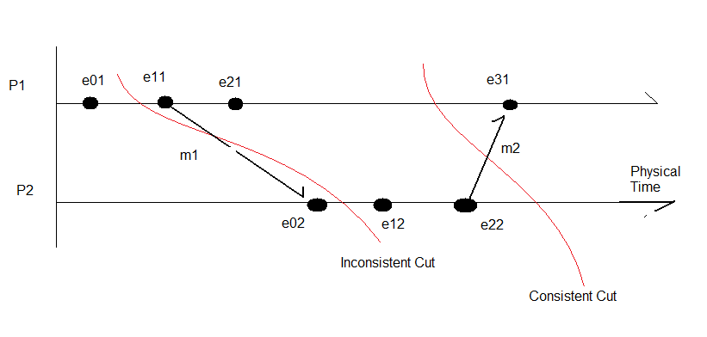
  + //TODO: get def of cut
  + C = h1^(c1) U h2^(c2) U h3^(c3)…hN^(cN)
  + Consistent “… “ 🡪“linearization”
* Chandy and Lamport
  + “Snapshot”
  + message – that doesn’t interfere with normal activity
  + Marker Receiving Rule (on Channel C):
    - If (process recorded state?)
      * Not recorded
        + record state of Channel C as <empty> set
        + start observing mark on all other channels
        + execute Marker Sending Rule
      * Recorded
        + do the above as well as record the state of the channels
    - // both must happen atomically
  + Marker Sending Rule
    - record your state
    - send out marker message on all outgoing channels
  + How do you start?
    - any process can start the algorithm by pretending that a marker message was received (on no channel)
  + When the marker message comes in you begin recording
  + 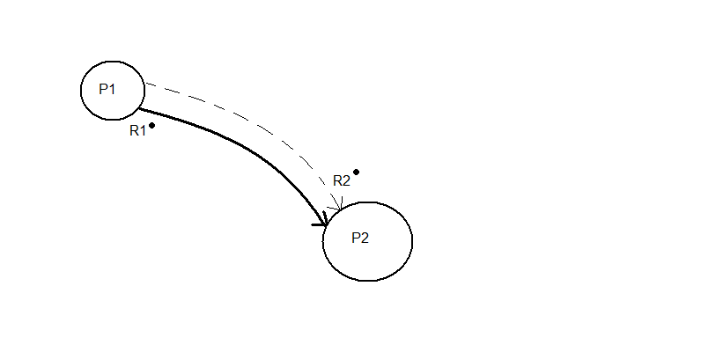
  + 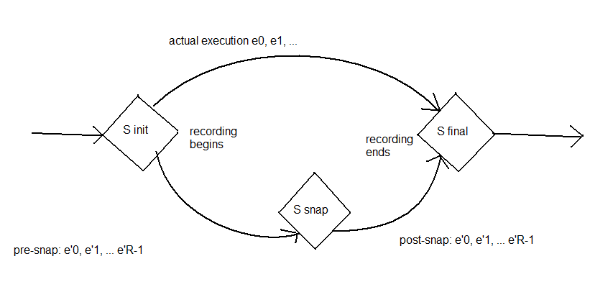
* We will begin a new chapter: Transactions and (something)
  + “this involves databases”
  + examples of transaction in database
    - queries
    - (send command and receive confirmation)
  + Transaction (DEF):
    - a container
    - ??
    - list of actions that needs to be handled as one
  + ACID
    - Atomicity – transaction can be done as a whole or not at all
    - Consistency – a series of actions takes from one consistent state to another consistent state
    - Isolation – one transactions does not have side effects other transactions
      * you should feel as if it’s you and the database only
    - Durability – once a transaction occurs the system is durable. transactions to permanent storage

TODO:

* Look into Christian’s Method
* Look into Berkley method